I completed the task in the following steps:

**1.Creating the container (applicationContext.xml):**

*follow WEEK3\LibraryManagement\src\main\resources\applicationContext.xml*

* Defined a *BookService* bean and injected the repository using setter injection.

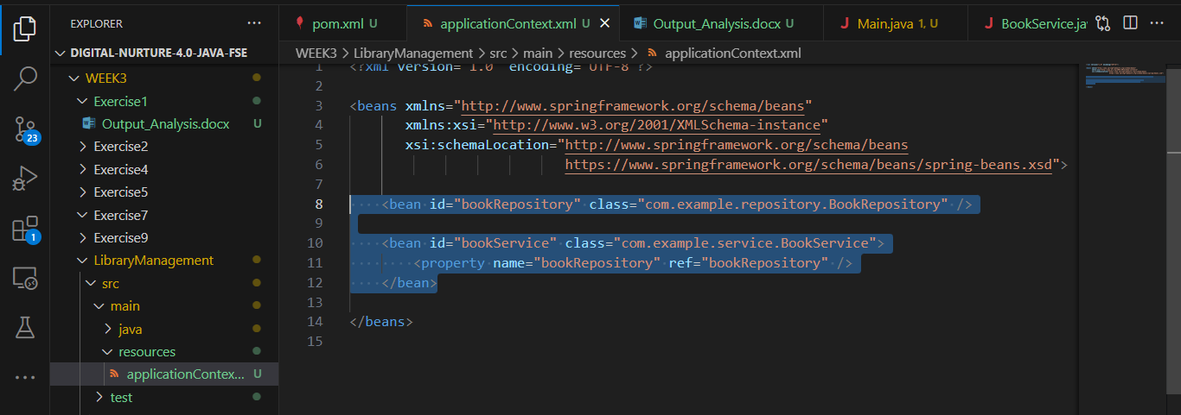

4. **BookService Class updaed :**

* *BookService* had a *setBookRepository()* setter for injection and an addBook(String title) method that called *saveBook().*

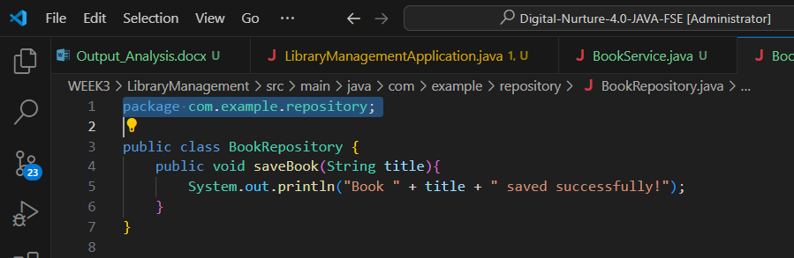

#### 

#### 

#### **5. Main Application**

* Created Main.java in com.example.controller.
* Loaded the Spring context using ClassPathXmlApplicationContext.
* Fetched bookService bean and called addBook("Secret History of Mongols").

**Output(Screen shot):**

